Step:-1 Go to Autodesk Educational website with following link

<https://www.autodesk.com/education/edu-software/overview?sorting=featured&page=1>

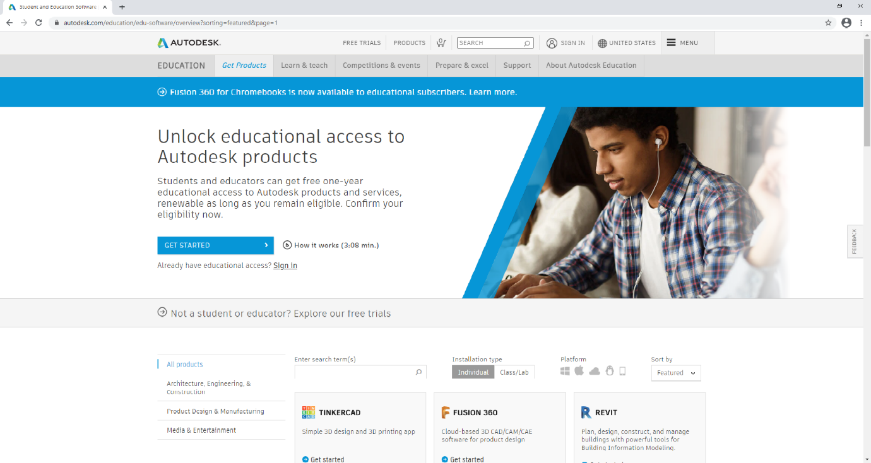

Step:-2 Now click on Sign In you will get following window and click on CREATE ACCOUNT

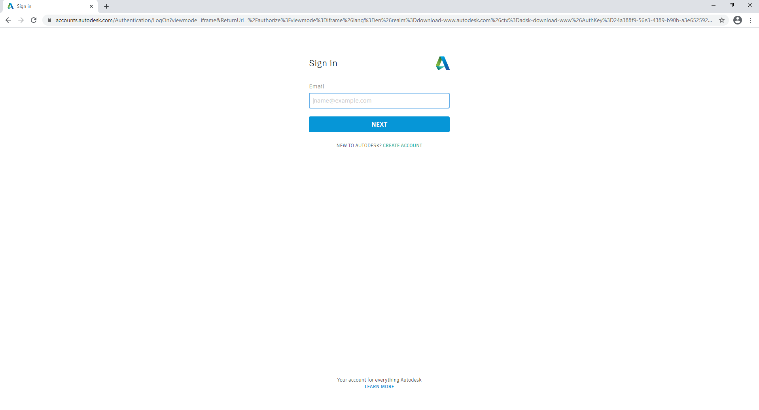

Step:-3 Create your educational account

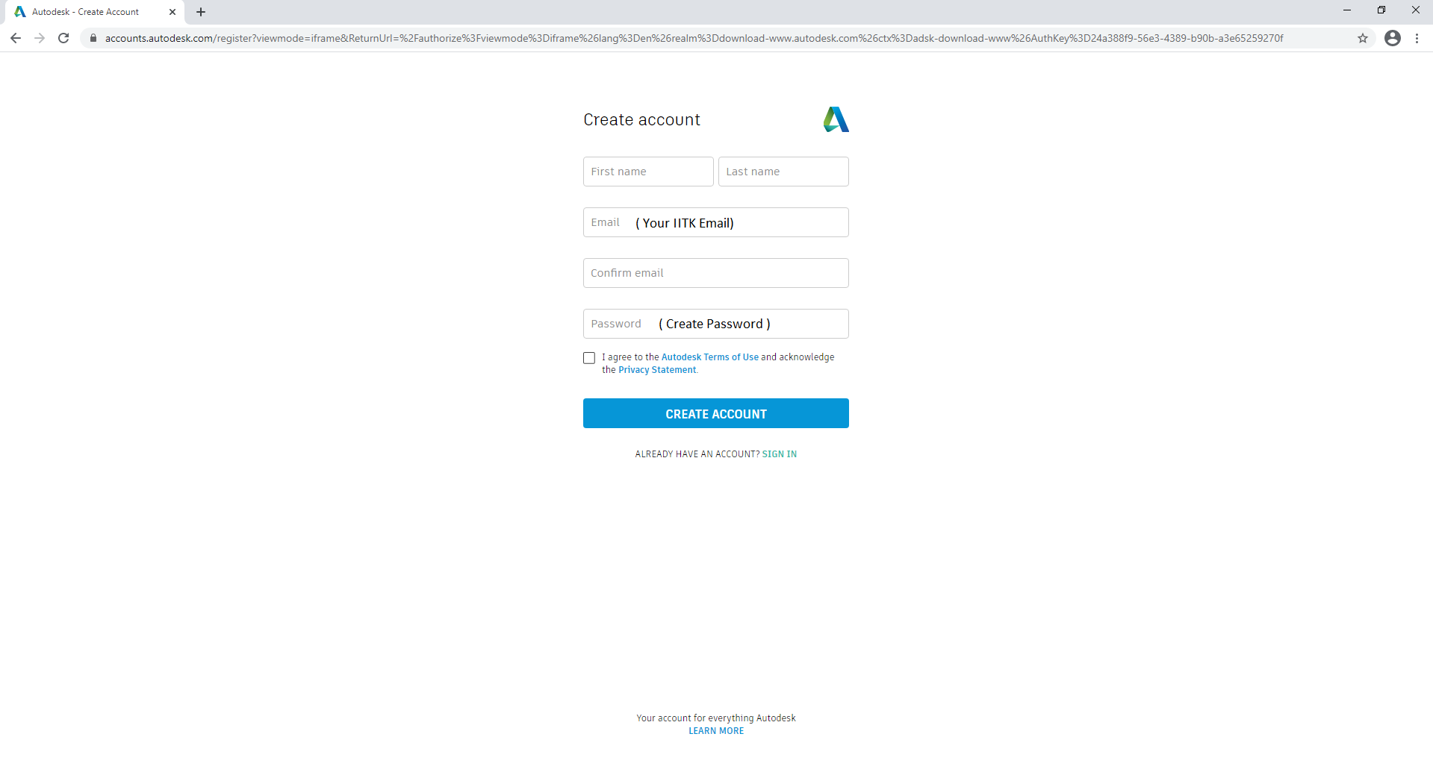

Step:-4 Now login with your register ID and Password



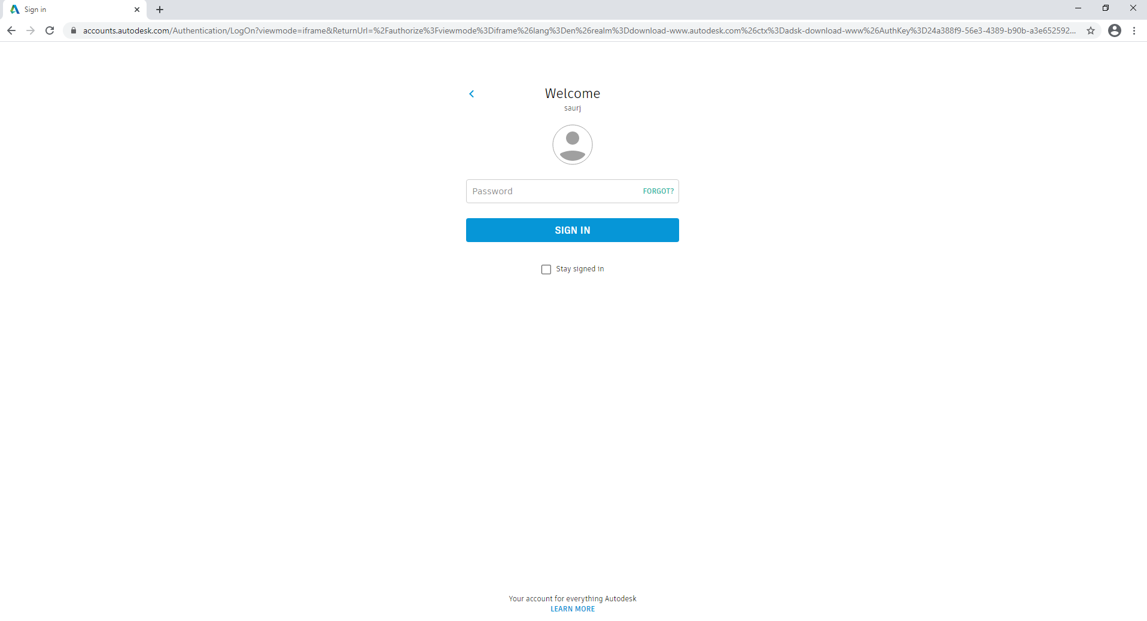

Step:-5 You will this window and click on GET STARTED

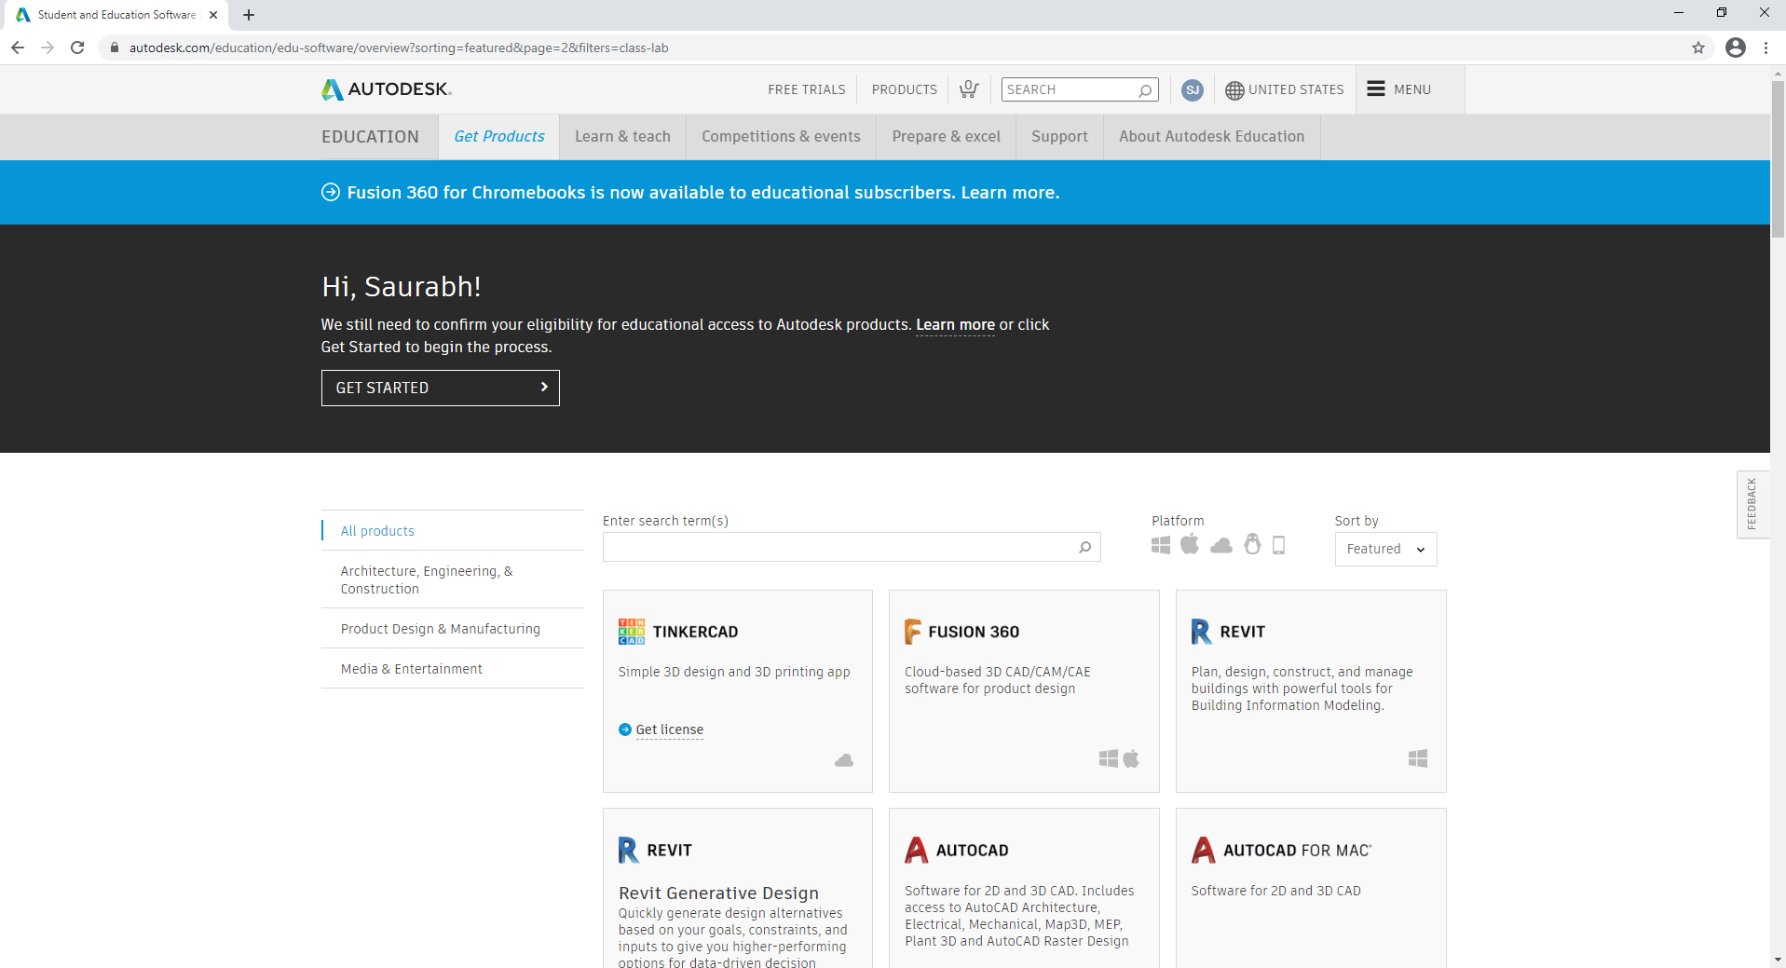

Step:-6 Now complete your educational profile

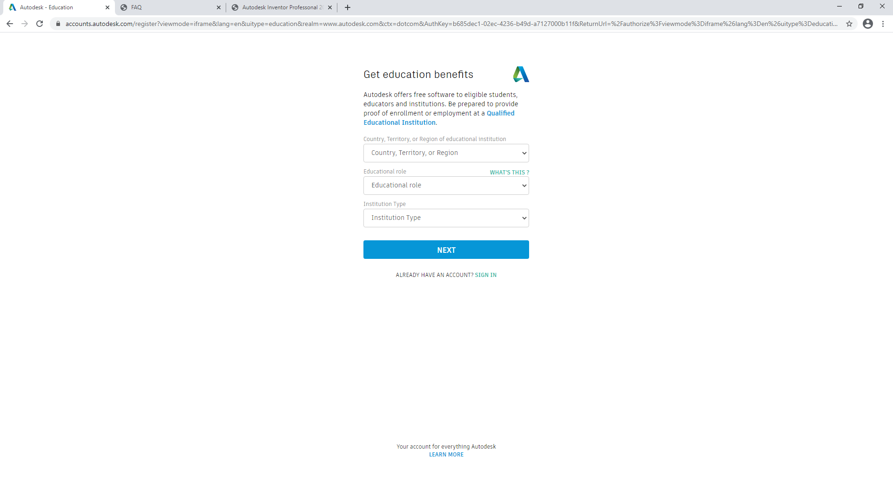

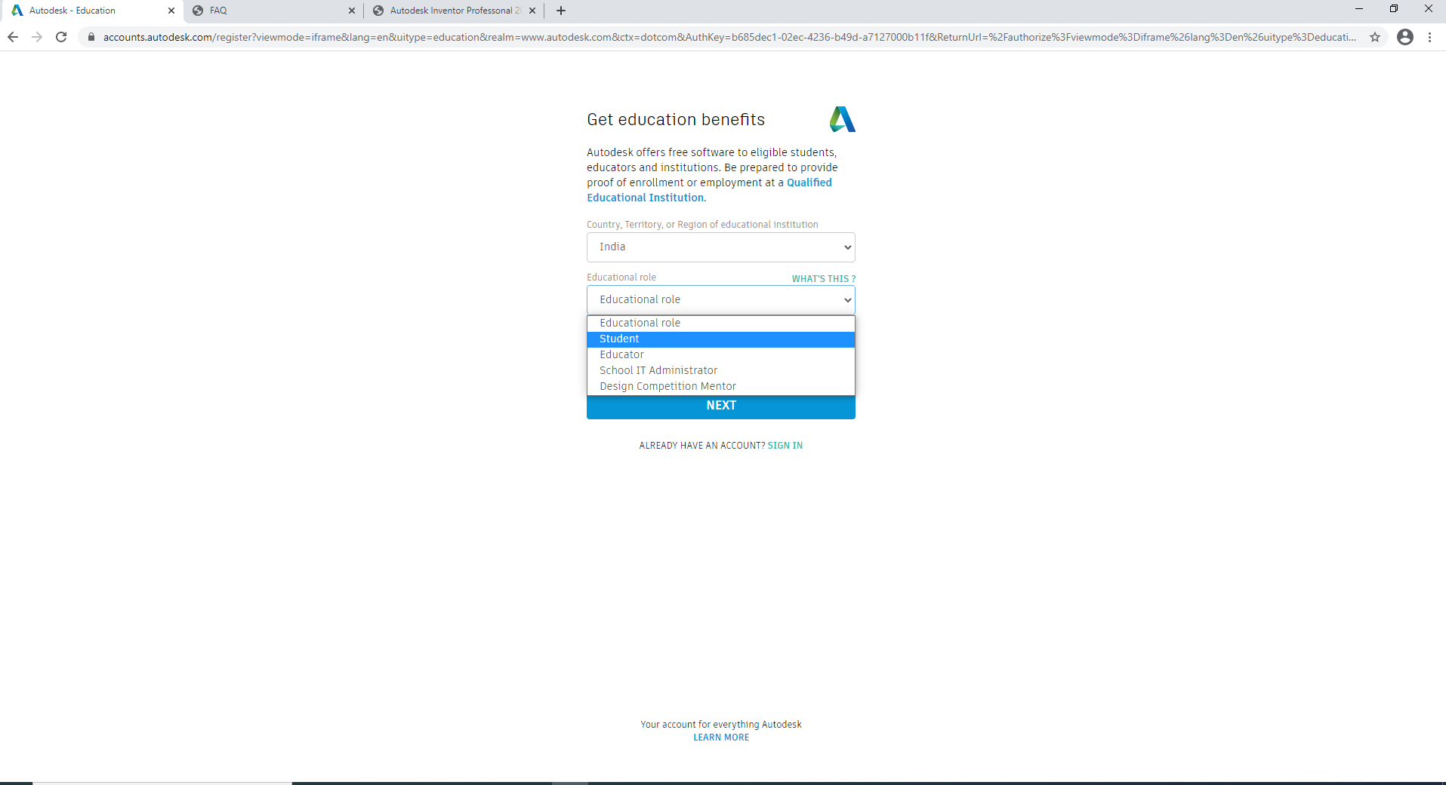

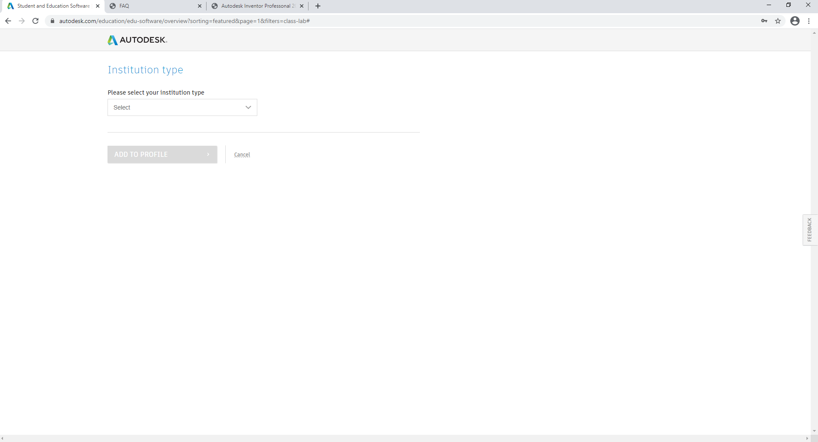

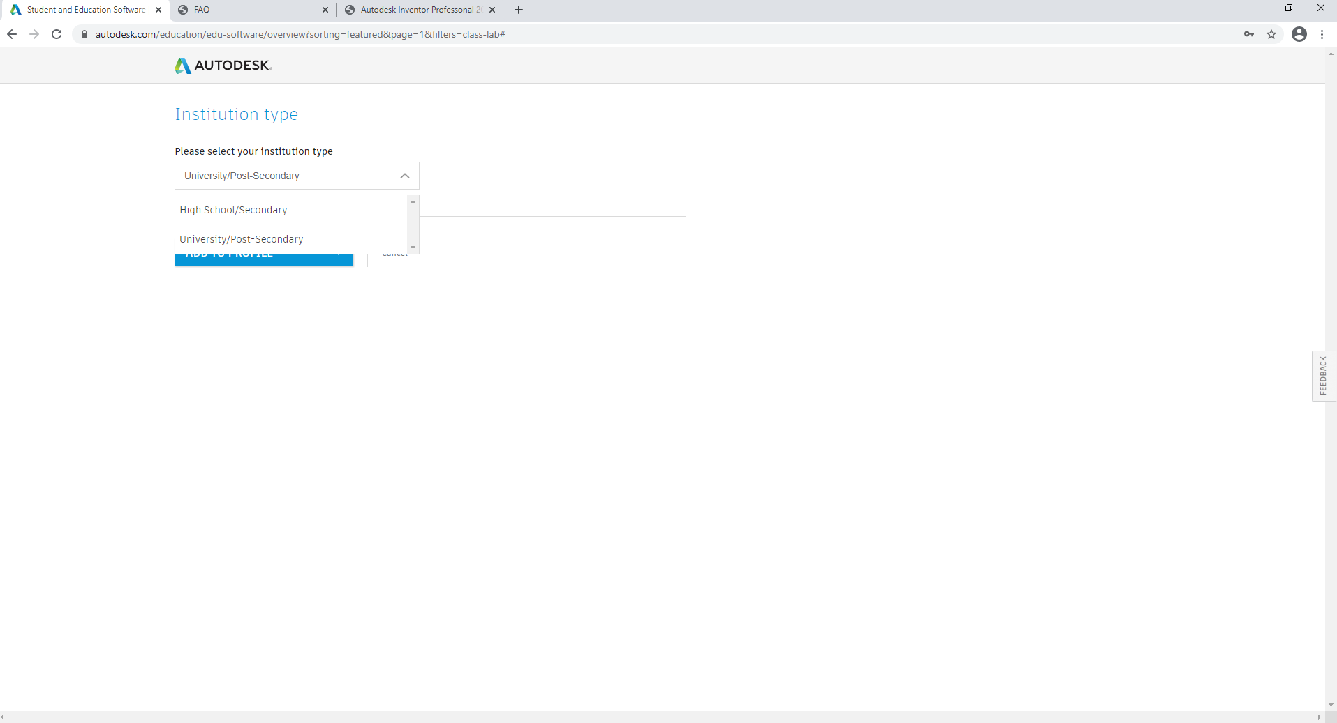

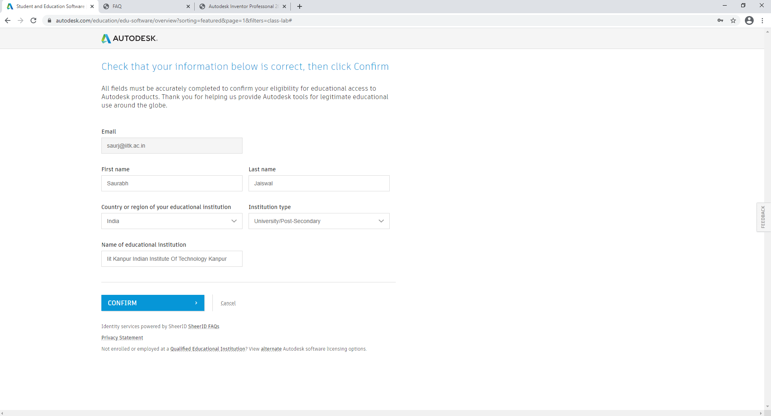

Step:-7 Now upload your ID to complete the process

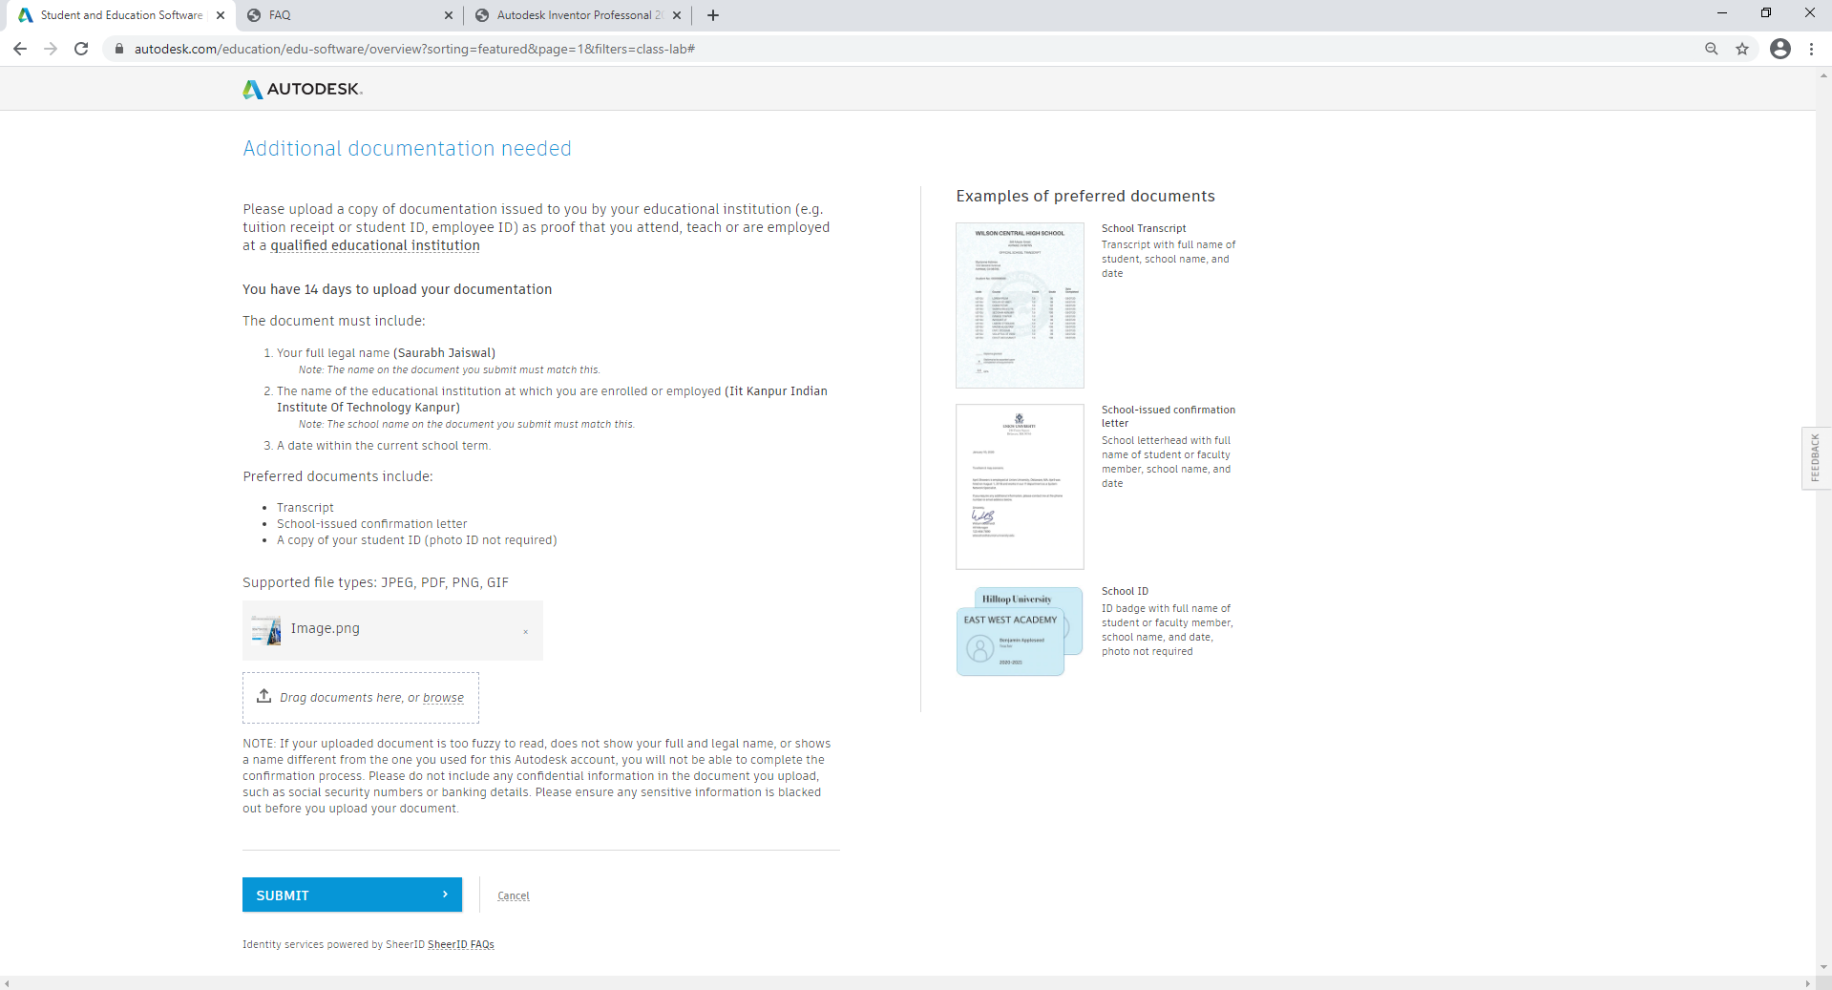

Step:-8 After 48 Hours your account will verify from Autodesk. After verified you can download and install any Autodesk product.

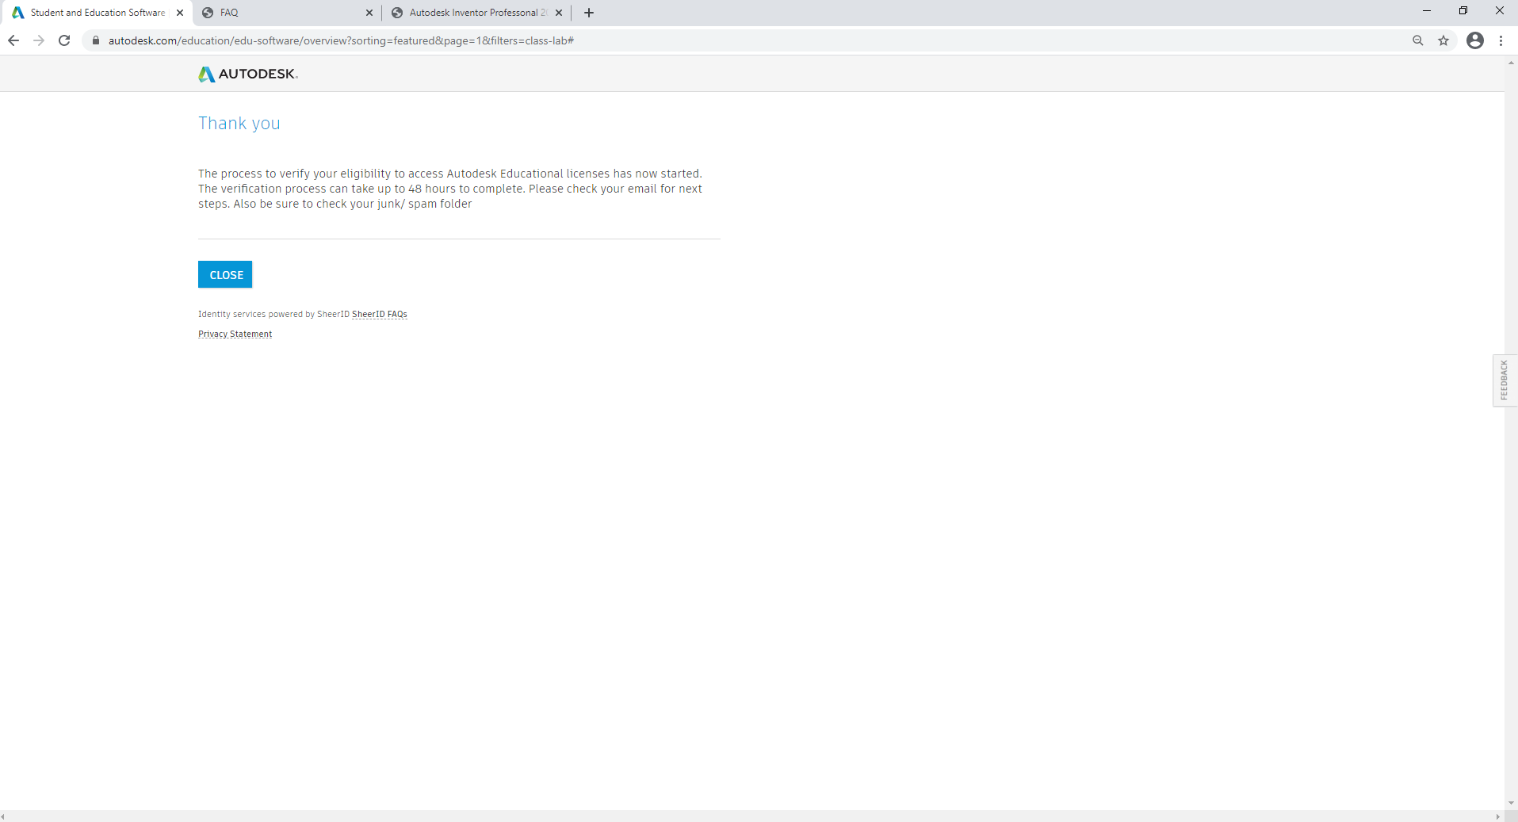

**How to install a Autodesk Product**

**Installation guide for 2021 Autodesk Inventor Professonal**

1. Run the Autodesk 2021 “setup.exe”. Setup Initialization.

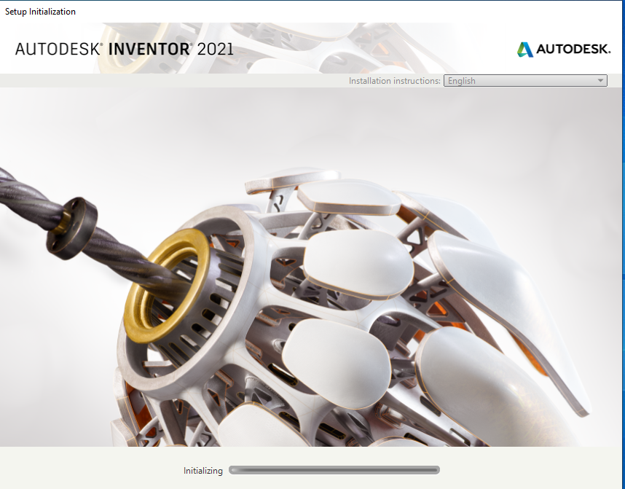

1. Click on the “Install” button.

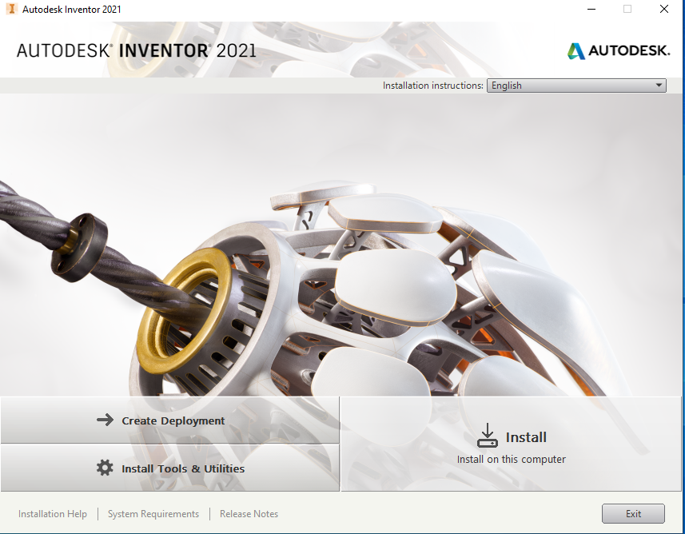

1. Read the License Agreement carefully then select “I accept” button and Click on “Next” button.

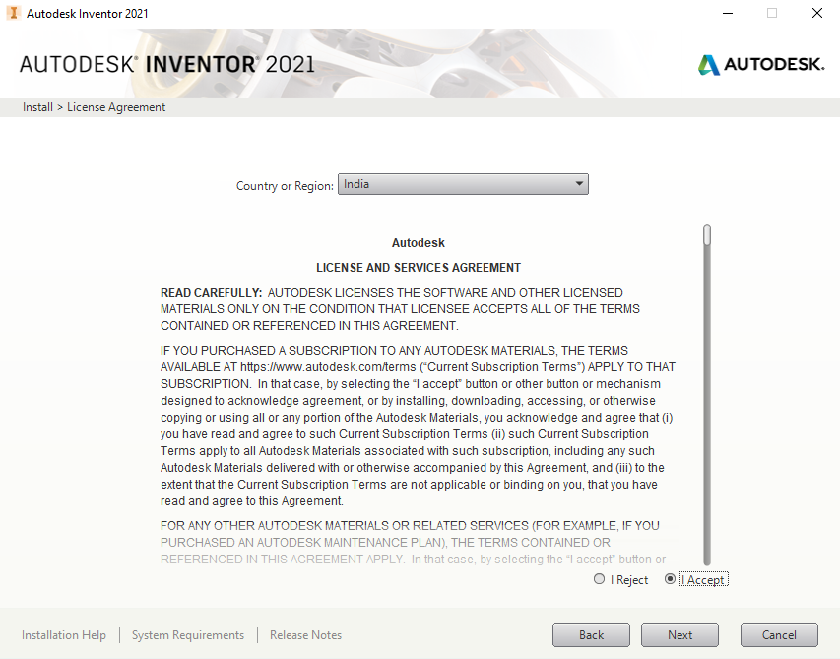

1. Choose the “Autodesk Inverter Professional 2021” product to install and Click on “Next” button.

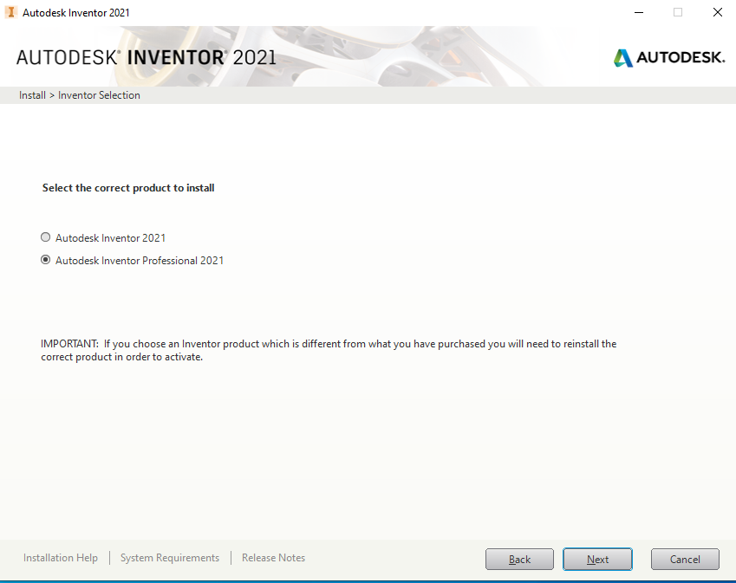

1. Select the Installation folder path from local drive. Choose the default folder path and Click on “Install” button.

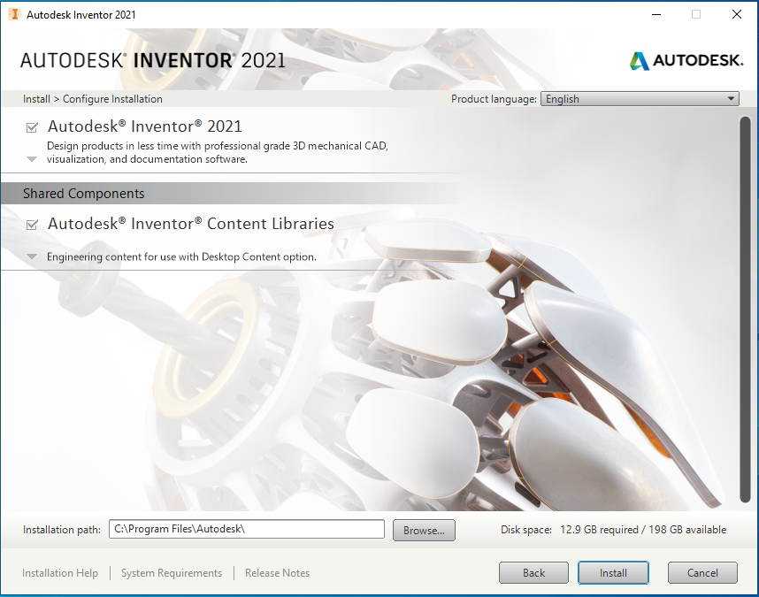

1. Wait a several minute for the installation complete.

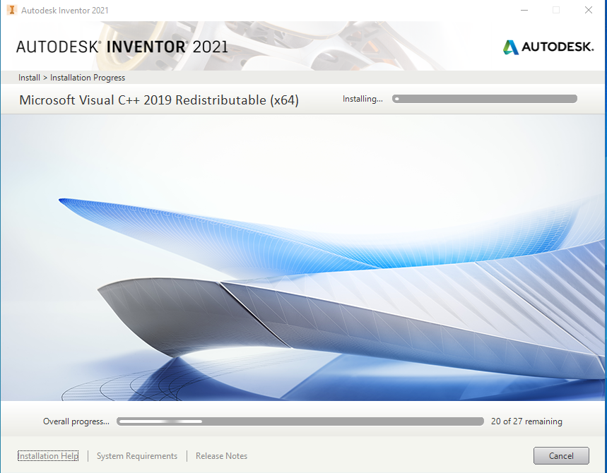

1. Installation is finished, and Click on “Finish” button.

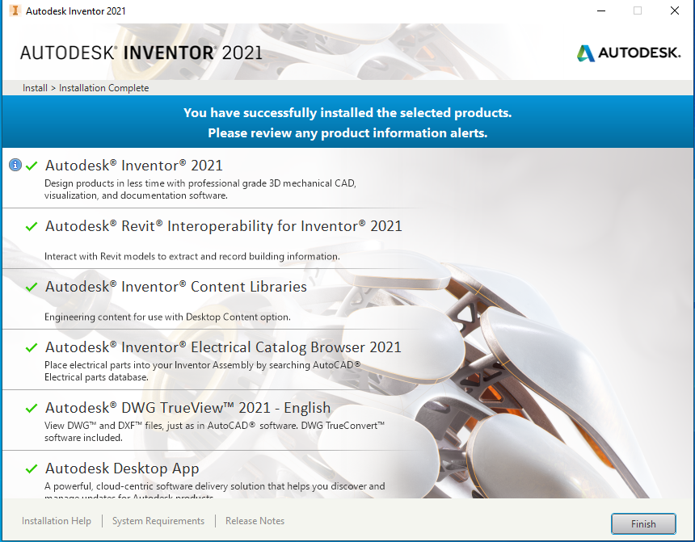

1. Click on “Yes” button for restart system.

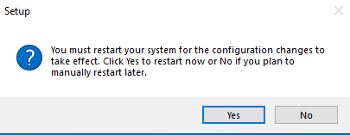

1. Launch Autodesk Inverter 2021. And Select “Use a network license” option. 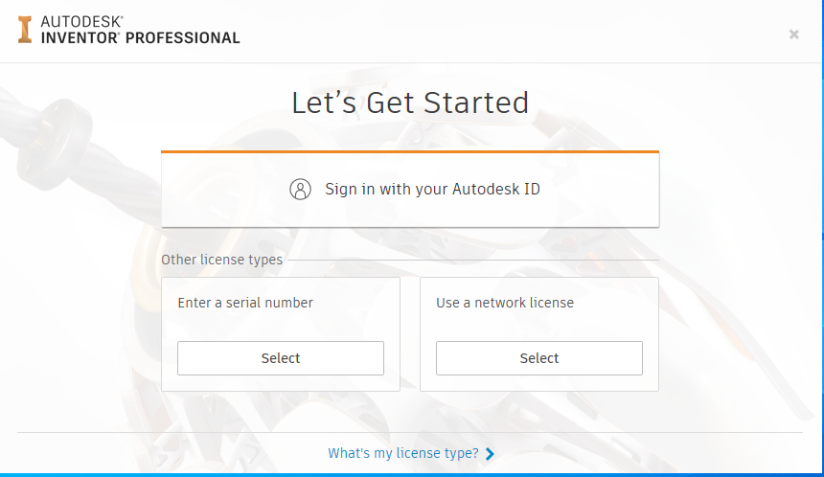
2. “Specify a license server”. Select Single Licence Server model and Enter the Server IP Address is “**172.31.1.12”**

